Task A: AI Conversation and Mind Map

LIST OF QUESTIONS ASKED
- Initial Goal & Exercise
  - "Hi ChatGPT, I'm a 34-year-old mom of two. I currently weigh 180 pounds and I hope to lose 25 pounds within the next six to nine months. Can you tell me what kind of exercises you would recommend for me to achieve my goal?"
- Progressive Plan
  - "Can you create a six-month progressive plan for me? Starting light and gradually increasing intensity, so it feels structured and sustainable."
- Weekly Template
  - "Can you make a weekly schedule template for me? I think it should all be easier for me to stick to."
- Diet vs Exercise
  - "So, I've heard that dieting is more important than exercises for weight loss. How true is that?"
- Weekly Meal Plan
  - "Can you provide me with a weekly meal plan?"
- GLP-1 Medications (General)
  - "What do you think about GLP-1 medications for weight loss?"
- GLP-1 Recommendation
  - "Would you recommend I go on a GLP-1 medication for my weight loss goal?"
- GLP-1 Side Effects
  - "What are the common side effects for GLP-1 medications?"
- Diet vs Exercise vs GLP-1
  - "If I had a choice to choose between dieting, exercising, and taking GLP-1 medications, which would you recommend?"

TASK A – MIND MAP
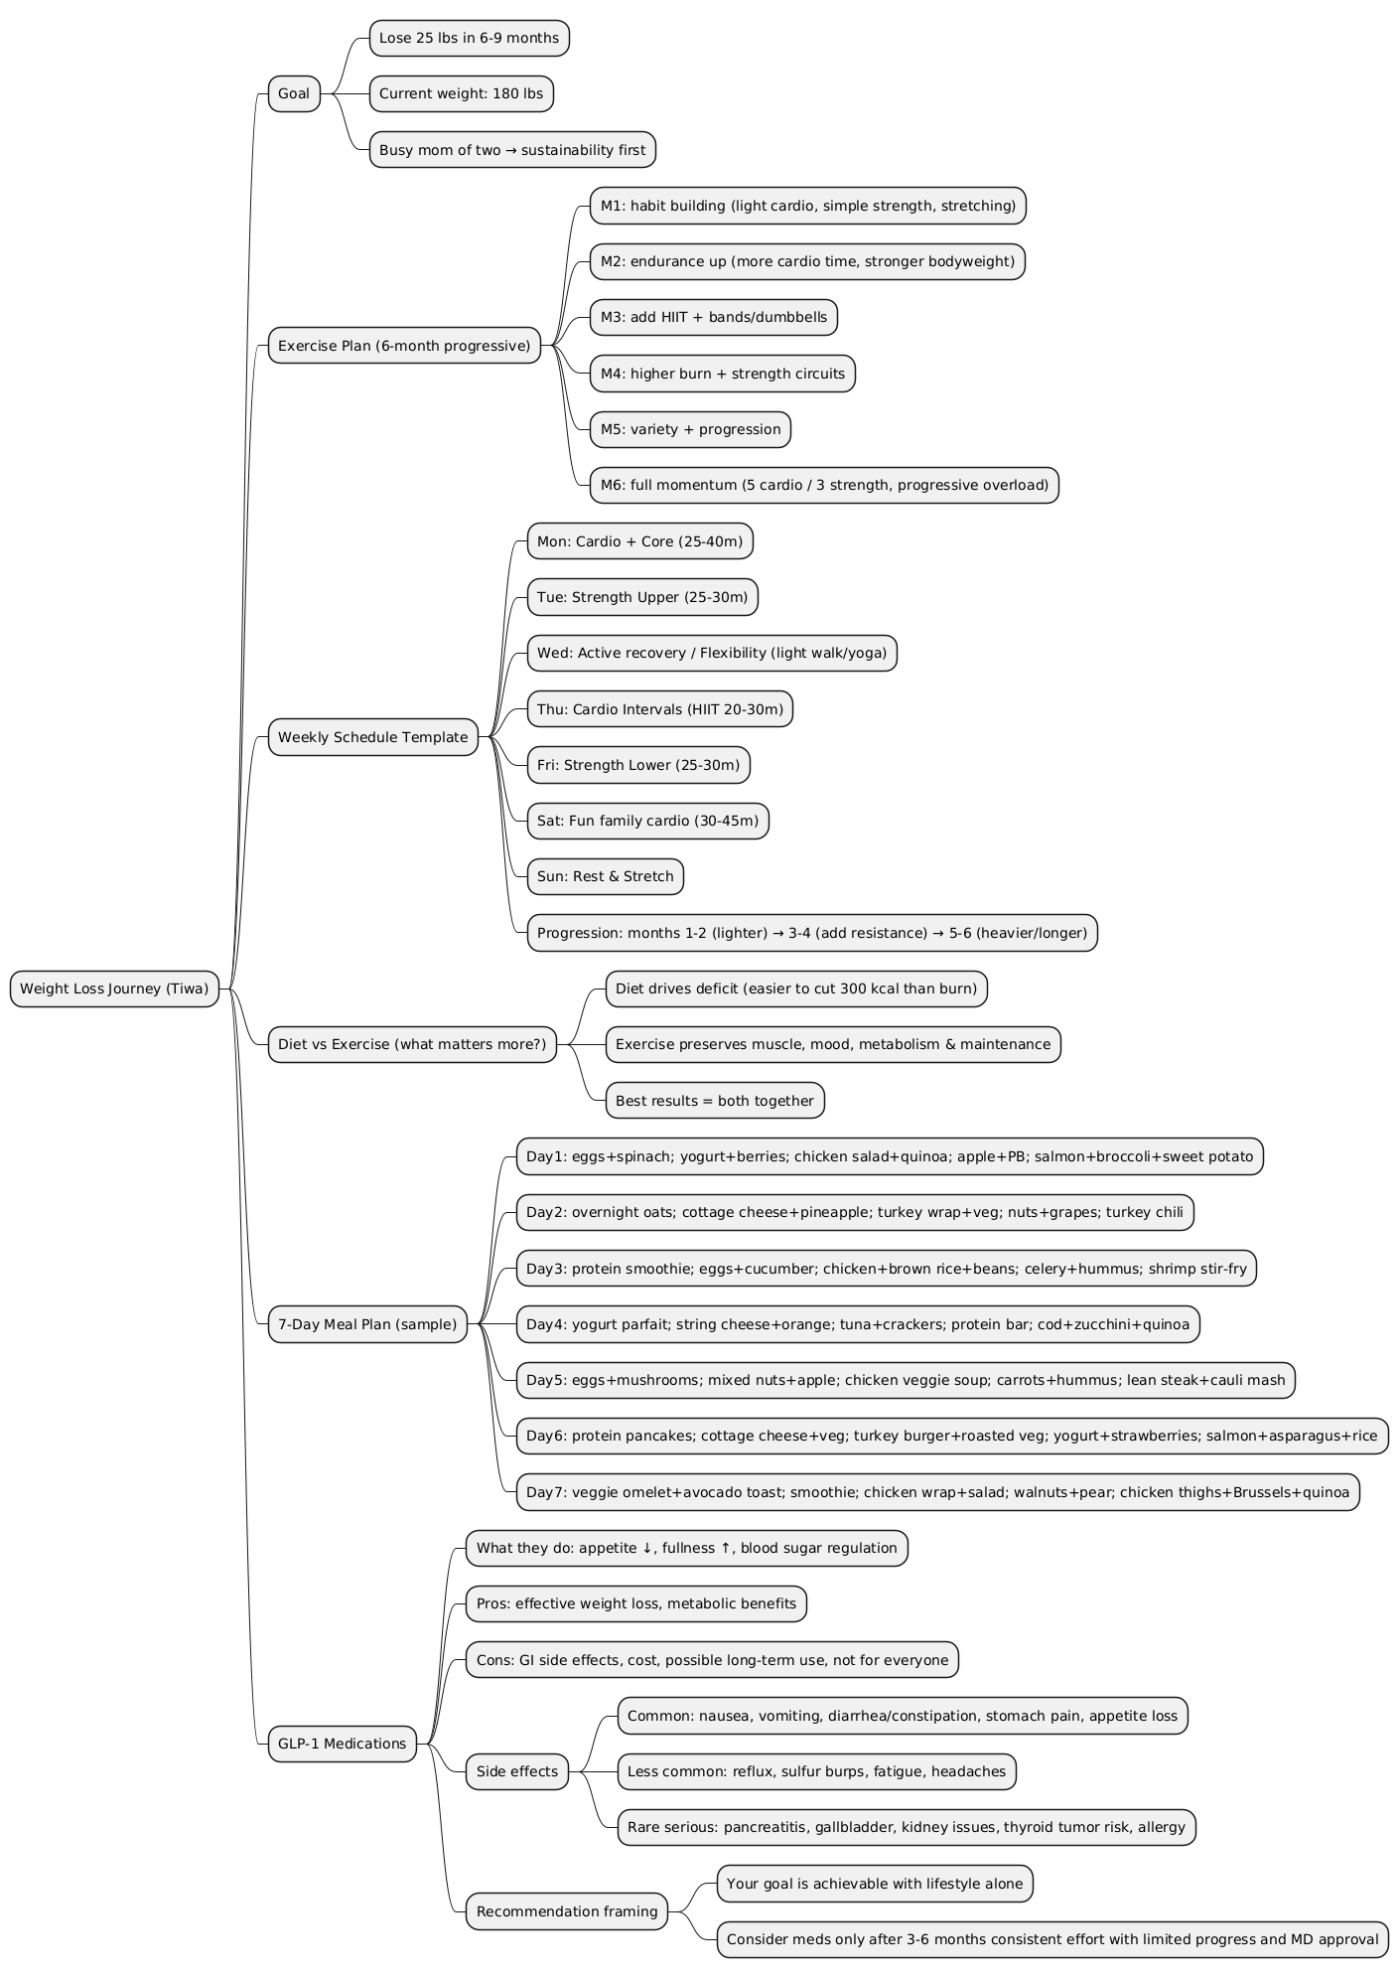

Task B: Role Play a Difficult Conversation

Reflection
I had a conversation with AI that I found both profound and engaging. Unlike humans with limited knowledge, AI draws from a vast pool of information and can provide answers to almost any question. What stood out to me, especially with ChatGPT, is its ability to adapt its tone to my preference, whether informal or professional, and tailor responses based on my needs, even offering tools like printable self-improvement plans. In many ways, AI serves as a mirror of our thoughts, offering in-depth insights shaped by the conversations we have with it. In our role-play, I stepped into the shoes of a manager giving a difficult performance review to an employee named Alex, whose performance was below expectations. Through this exercise, I realized that I was able to balance constructive criticism with support, set clear expectations while showing empathy for personal circumstances, and clarify priorities in a way that built trust and gave my employee a clear sense of direction. At the same time, I identified areas for my own growth as a manager, including checking for understanding more consistently, inviting employees to co-create improvement plans, and maintaining an ongoing feedback loop rather than waiting for formal reviews. This exercise reminded me that leadership is a skill I can keep sharpening, and with more practice, I can become the kind of manager who both supports and challenges my team in meaningful ways.

[Written by me. Edited and fine-tuned by ChatGPT5]

